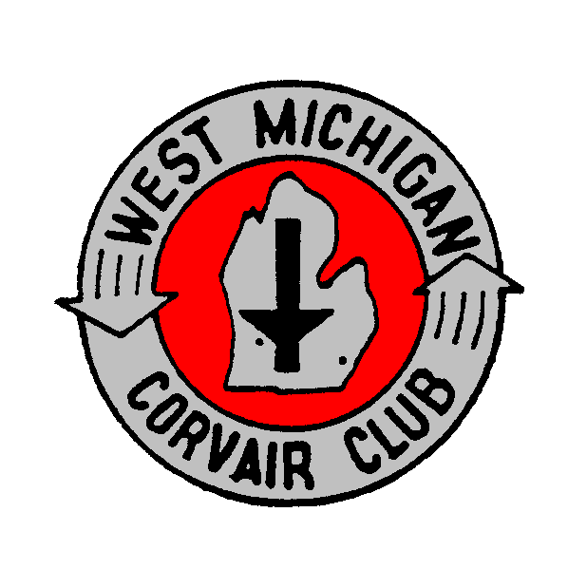
West Michigan Corvair Club Application:
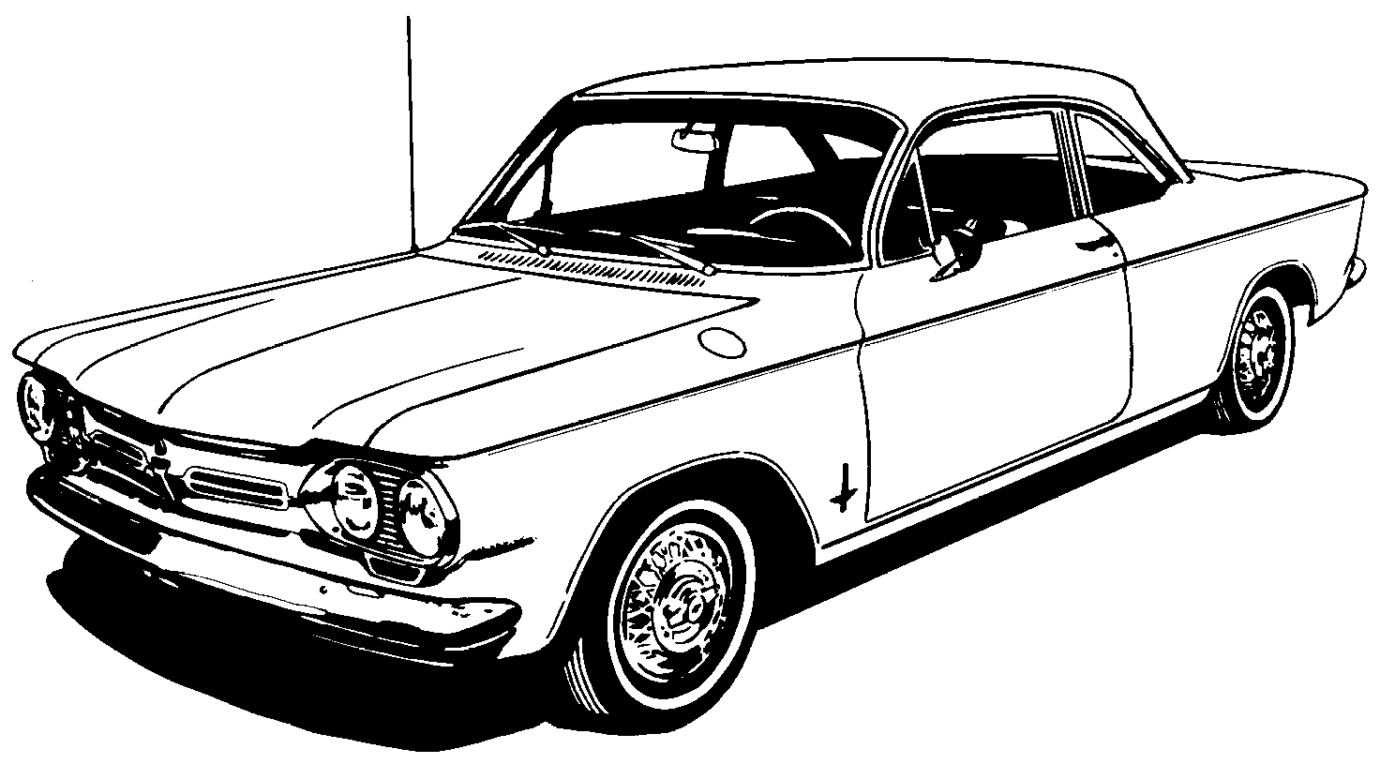
Name:

Address:

City, State, Zip:

Year, Model of Corvair:

Phone Number:

Email Address:
Please mail this form, along with a check for $25.00 to:

West Michigan Corvair Club
7769 Burlingame Ave. SW
Byron Center, MI 49315

Spouse's Name:

Children’s Names:

1.

2.

3.

4.

